**DEVELOP THE PYTHON SCRIPT**

**TEAM ID:PNT2022TMID08486**

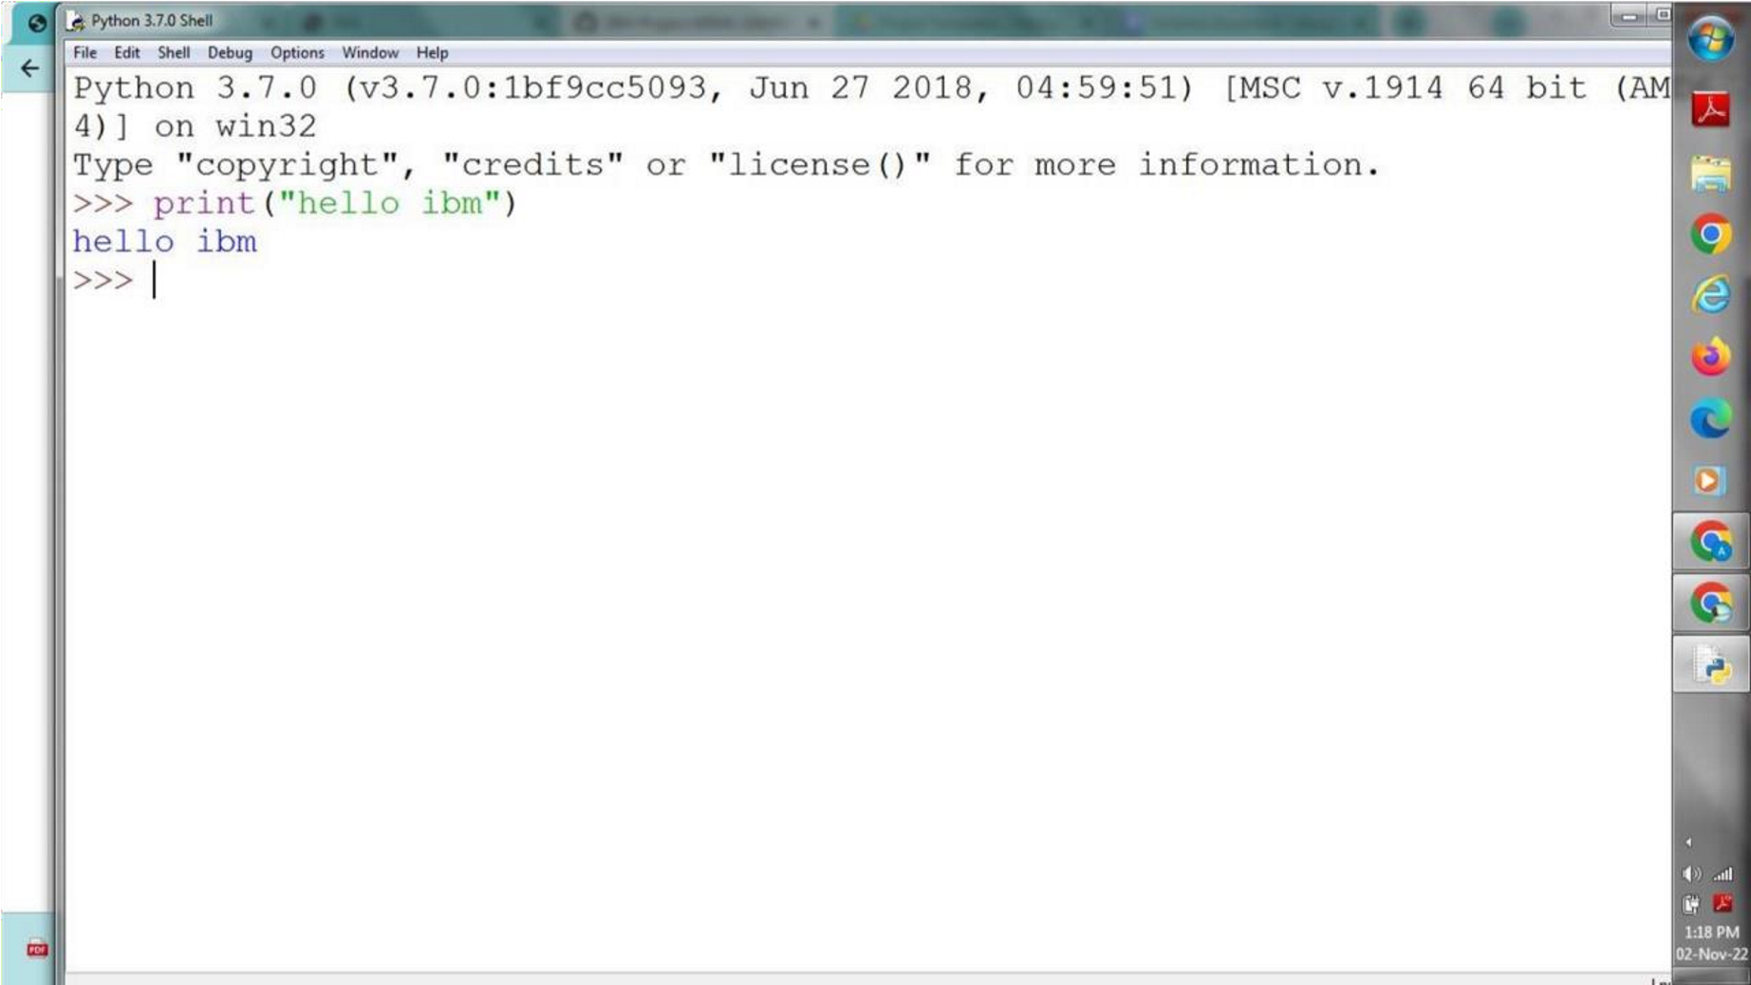

SUBMITTED BY:

* RISHALIN M (810419106050)
* RAJASUSHMITHA R (810419106043)
* RAMYA T (810419106046)
* SAJITHA CHANDRAN S (810419106053)